***SOLID ROCKET MOTOR PRINCIPLES***

1. **Thermodynamics**
2. **Fluid mechanics**
3. **Motor combustion chamber**
4. **Converging-diverging nozzle**
5. **Designing a solid rocket motor**
6. **Thermodynamics**

In this first chapter the basic theory and relations of thermodynamics will be reviewed. The derivations can be found in every thermodynamics textbook and are not included in this booklet.

The first great principle, mandatory for the analysis of the flow inside the motor is off course the **1st law of thermodynamics**, the conservation of energy. For an open system the 1st law for a infinity small stationary (relative to the flow), control volume is described by equation 1.1

Where p is the pressure, ρ is the density, e is the inner energy per unit mass, V2 is the square of the velocity per unit mass, w is the exchanging work per unit mass and q is the exchanging heat per unit mass.

We define the first differential term as enthalpy, h and the sum of the first 2 differential term as total energy as shown in the following relationships:

For an adiabatic system, that is to say no heat is exchanged between the fluid and the borders of the control volume, the last term of equation 1.1 is equal to 0. The term of exchanged work is referred to energy exchanged duo to moving shaft. Under these assumptions equation 1.1 leads to 1.4:

By integrating over a distance between two points 1,2 we derive the important equation 1.5, the **conservation of total enthalpy**.

Next, using the equation 1.5.2 we define the total temperature, as the temperature at a point in the flow where the velocity is equal to zero.

Solved for velocity

The equation 1.7 solved for the velocity is going to be the beginning of the derivation of the nozzle exit velocity in the following chapters.

We must also mention the **2nd law of thermodynamics** in our analysis. If a process is adiabatic and reversible (in practice, no energy loss from viscous effects), then the total change of the entropy is equal to zero.

The flow we analyze can be assumed as adiabatic and reversible, cause the velocity is high and the boundary layers, which normally create losses and increase of entropy, are negligible.

The following relations can be used:

γ is the isentropic exponent of the gas.

To sum up the useful relations, we will also use the change of entropy for a non isentropic change between two points, which will be used for the calculations when a normal shock wave takes place:

1. **Fluid mechanics**

To apply the theory of fluid dynamics to the rocket motor, we will use the following assumptions:

* Steady flow (all variables are a function of place, not time)
* 1d axial flow
* Adiabatic flow (no heat exchange) with negligible viscous effects, and so the flow is considered isentropic

The first useful expression which will be used a lot in the following chapters is the local Mach number, an expression for the velocity, V, in comparison with the local speed of sound, a.

We now introduce the quantity of total pressure using equation 1.10, which like total pressure is the pressure at the point where the velocity of the fluid is equal to 0.

By combining the definition of total temperature 1.6.2 with the mach number equation 2.1 we get the mach number relations equations:

The last equation we need is the conservation of mass, which for a our assumptions takes the following form:

A is the cross sectional area normal to the velocity of the fluid.

We have introduced all the basic thermodynamic and fluid mechanic concepts and we can now begin the analysis of the nozzle and the combustion chamber.

1. **Motor combustion chamber**

With this chapter we begin the main analysis of the rocket solid motor. We will describe the components of a typical combustion chamber, derive and show the solution process of the equations, which describe the exhaust gas generation and the pressure growth needed for an efficient functionality.

Let’s begin with the main components. A typical CC (Combustion Chamber) has:

* A Casing
* An insulator layer
* The propellant grains
* The spacers

The casing is the metallic cylinder which includes all the parts. It must be designed properly in order to endure the mechanic loads due to the high inner pressures. 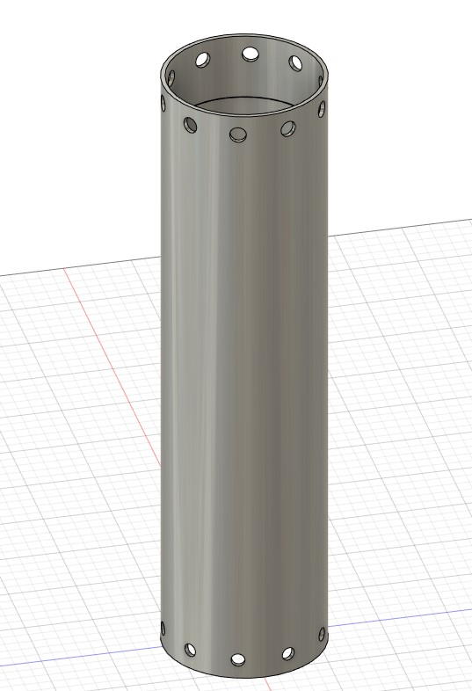

**Picture 3.1: A typical solid motor casing. We can see the holes at the north and south side, necessary for a screw fit with the bulkhead and the nozzle.**

The insulator layer is also a cylinder, made from a material with low diffusivity, which will not let the heat generated by the combustion to weaken and damage the casing. It usually consists of materials like hard paper. It must be constructed in such a way, in order to have the following properties:

* It must be compact as a PVC-type object (in contrast with the material which is made of).
* It must fit tightly with the casing in order the final assembly of the motor to be compact.

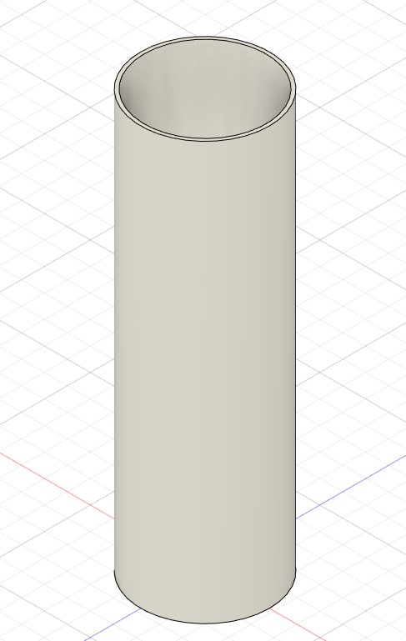

**Picture 3.2: An insulator layer of a solid rocket.**

The propellant grains are the part of the motor which will be burned and produce high temperature gasses. They are cylindrical and have a hole in the middle which denotes the initial burning surface. The surface will expand till the outer surface of the grain. Then the combustion will end and the motor will have concluded its purpose.

The grains have also an outer layer, the inhibitor, which insulates the outer surface from the heat, protects it from combustion and is typically made of craft-paper.

The cross- sectional area of a grain can by cylindrical, star-based etc and influence greatly the produced pressure and the duration of the combustion.

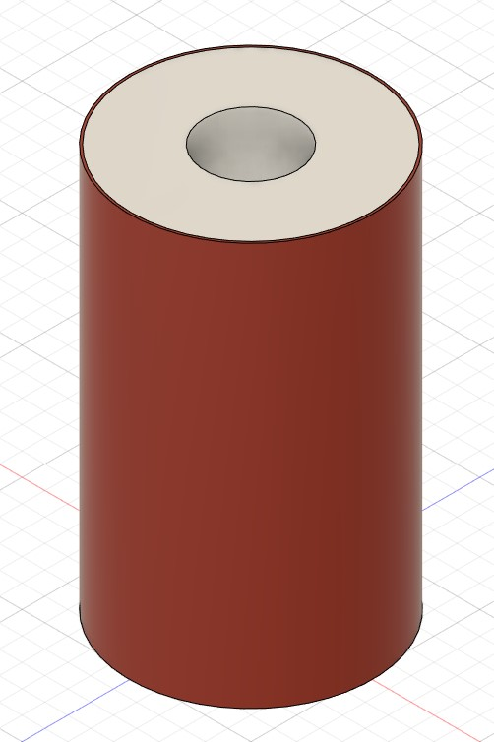

**Picture 3.3: A typical grain with a cylindrical cross-section area. The red outer layer is the inhibitor.**

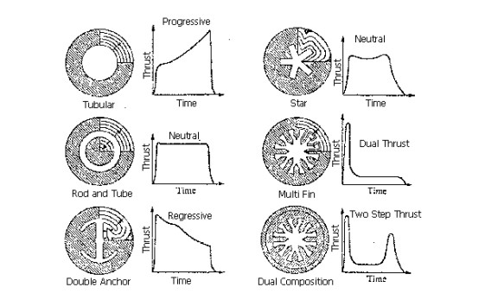

**Picture 3.4: Cross-section areas of grains and the produced thrust curves.**

Finally the spacers are metallic or plastic cylindrical parts which provide space between the grains. They are typically used for cylindrical cross-section area grains, in order to adjust the burning area and keep it relatively stable in every time moment. This topic will be analyzed more in detail in the mathematical formulation part of the chapter.

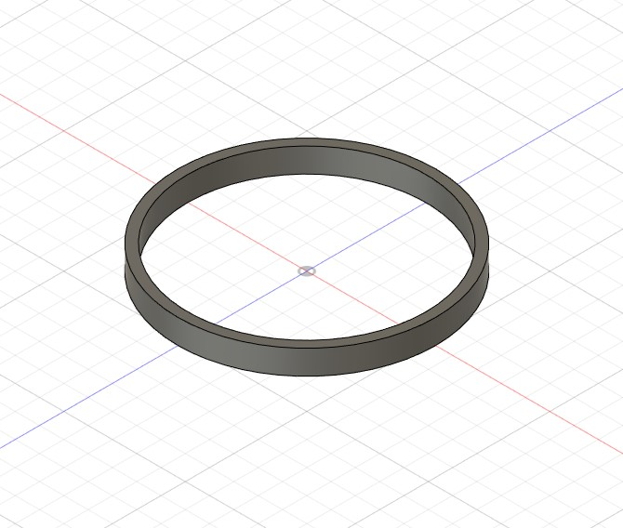

**Picture 3.5: A typical metallic spacer.**

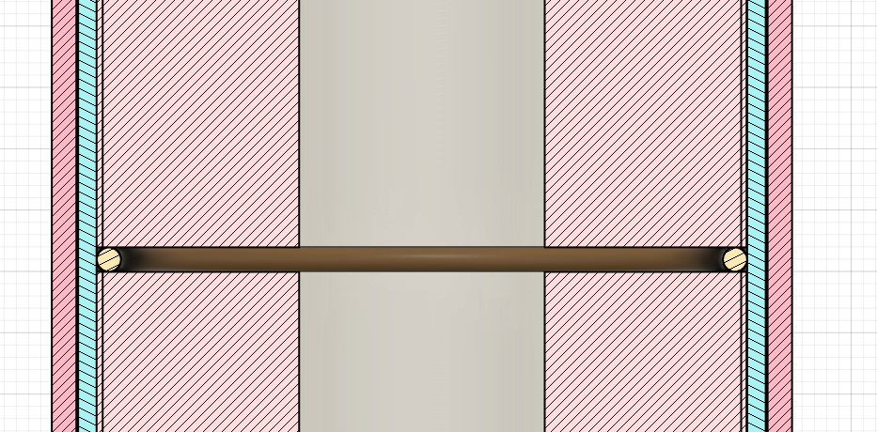

**Picture 3.6: The placement and usage of the spacers inside the motor (yellow parts).**

The following pictures clearly show the final assembly of the CC and also of the complete motor, with the converging-diverging nozzle and the bulk head (the component which insulates the back side of the CC and doesn’t let the gasses flow in the wrong direction).

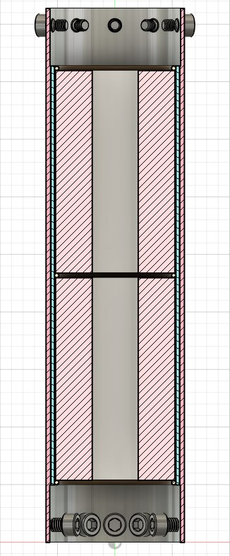

**Picture 3.7: The CC assembly with all its parts. The bright pink parts are the grains, the bright blue is the insulator, the darker pink is the casing and the circle-like parts between the grains are the spacers. The screws are used to bind the CC with the bulkhead and the nozzle.**

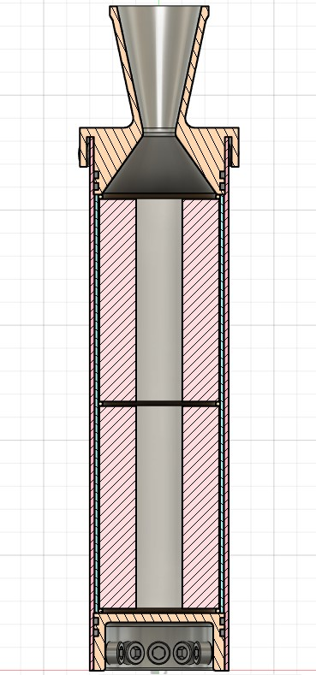

**Picture 3.8: The complete assembly of the motor.**

We now continue to the mathematical analysis of the phenomena taking place inside the CC. Like the previews chapter we must denote the assumptions of our analysis, which are the following:

* The propellant Burn Rate is only a function of pressure and is described by Saint Robert’s Law equation.
* The flow inside the nozzle is choked.
* The temperature inside the casing is constant and equal with the temperature of the generated gasses.

The Saint Robert’s Law mentioned above states that the propellant Burn Rate is given by equation 3.1:

Where is the pressure inside the CC, a the burn rate coefficient and n the burn rate exponent. The values of a and n depend of the type and quality of the propellant and can be found experimentally.

This is a ordinary differential equation. In our case, r is the inner radius of the grains. This equation cannot be solved yet, cause we have the unknown pressure, which we except is a function of time, like r.

Indeed to solve the problem we need a second equation, which is derived with the help of our little friend, the mass conservation.

We will study the mass conservation inside the control volume of the casing. The different mass flows, taking place in the CV (Control Volume) are the mass generated by the combustion, , the mass exciting the casing/the mass flowing inside the nozzle, , and the mass stored inside the casing, .

The conservation of mass is described by the following equation:

The term of the generated mass, can be expressed as:

Where is the density of the solid propellant, and are the burning areas and their corresponding burn rates. In our case:

Where is the total burning area of the grain. For a motor with a certain number of cylinder-cross-sectional area grains, the total burning area is equal to the inner cylindrical-radius-growing surface plus the top and bottom surfaces (if we assume perfect combustion). So for such a grain (which is the most common type of grain) is found by the following equation:

Where N is the number of grains, r is the inner radius of the grains, l is the length of the grains in every given moment, D is the outer diameter of the grains.

We can easily see that the time rate of change of the length is double the time rate of the radius (duo to the fact that the length is reduced from the combustion of 2 areas).

For

Where L is the initial length of the grains and the initial inner radius.

We conclude to the following equation for the burning area for the case of perfect combustion in every area:

In the case of combustion only in the inner surfaces of the grains, l is always equal to L and:

For the term by using the chain rule we have:

Where is the density of the stored gasses and the space the gasses possess.

Using the perfect-gas law we have:

The change in gas volume is equal to the volume change, duo to propellant combustion, hence:

And

Where N’ is the number of gaps inside the casing and s the gap-length.

Finally is given by the following relations, which will be derived in the next chapter:

*\*\* stands for the Mach number in the exit of the nozzle, for choked flow, but subsonic in the converging and diverging parts of the nozzle. stands for the value of the mach number, given the static to total pressure ratio of a point (in this case the point is the exit of the nozzle) given that the flow is isentropic. This of course may not be the case, if shocks occurs in the divergent part of the nozzle, but the function given by relation 3.14.3 gives always correct values of the Mach number in the converging part, and can be used to compare with the value of . For better understanding read the next chapter.*

Where and are the nozzle throat cross area and static pressure.

By combing the previews relations we derive the system of equations, which cannot be solved analytically. Computational methods like Runge-Kutta 4th order method must be used.

And are functions based by the grain geometry and combustion model. For perfect combustion and cylinder-cross-sectional area grains they are expressed by equations 3.8 and 3.13.

The system can be solved using the ChamberPressureSolver.hpp library, included in a .cpp file. The user defines the important geometric and physical values of the system in the Coef.hpp file.

For a perfect combustion the pressure curve has the following shape:

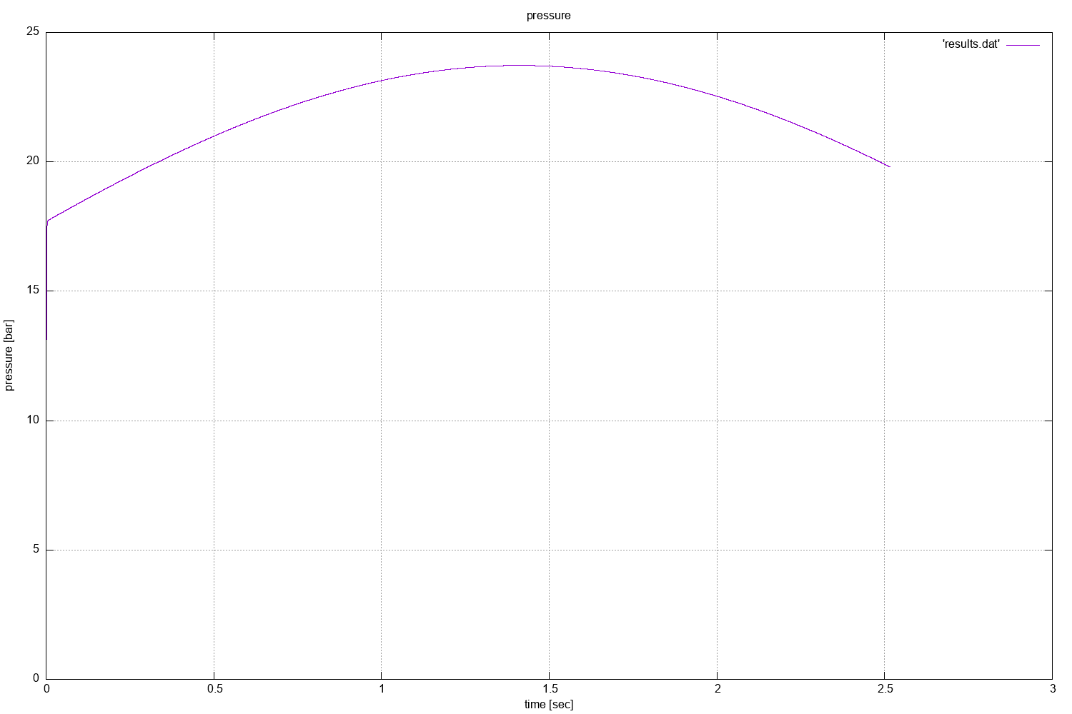

**Picture 3.9: Perfect combustion chamber pressure curve.**

And for a not perfect combustion:

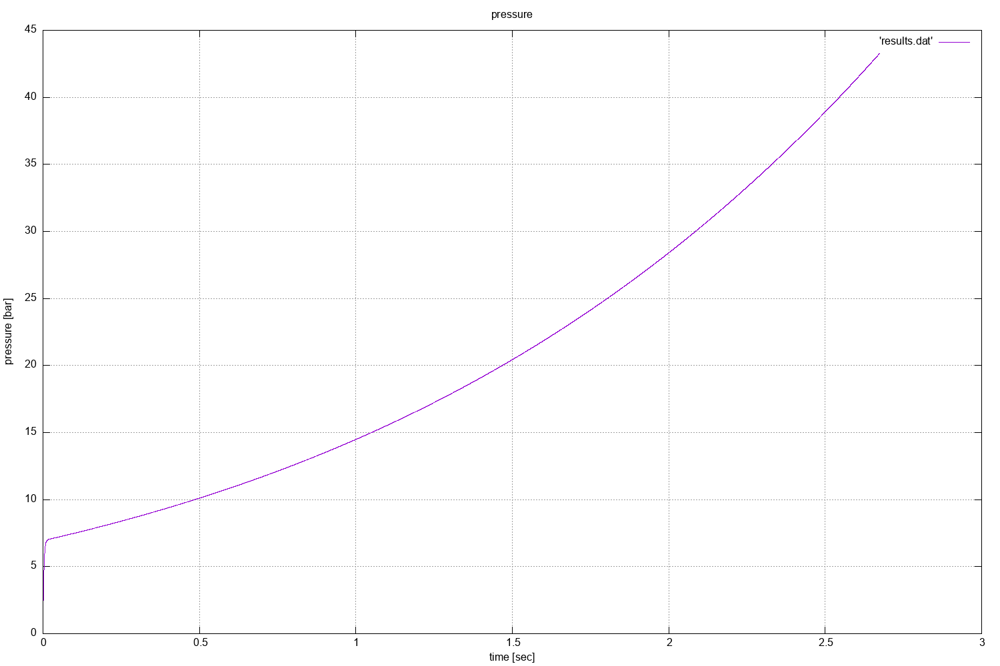

**Picture 3.10:** Not perfect combustion chamber pressure curve.

We see that for a perfect combustion, the pressure stays relatively constant, in contrast to the not perfect situation. As designers it is important to keep the pressure relatively constant, in order the thrust to remain relatively constant. Constant thrust means more stable and smooth flight conditions for the time period, in which the motor is functioning.

We can also organize the perfect and non perfect combustion by defining a factor f as:

Where

means and so we have the non perfect combustion case

means and so we have the perfect combustion case

For we have all the other cases.

Factor f can be determined experimentally.

Another more accurate assumption comes from the fact that the temperature inside the CC cannot become instantly equal with temperature of the generated gases. We can assume an exponential growth of the temperature, in a length of ~0.3 sec. In the Coef.hpp file the user can define the value of the length, by changing the tc variable.

That way, more accurate results can be found as shown in the picture 3.11:

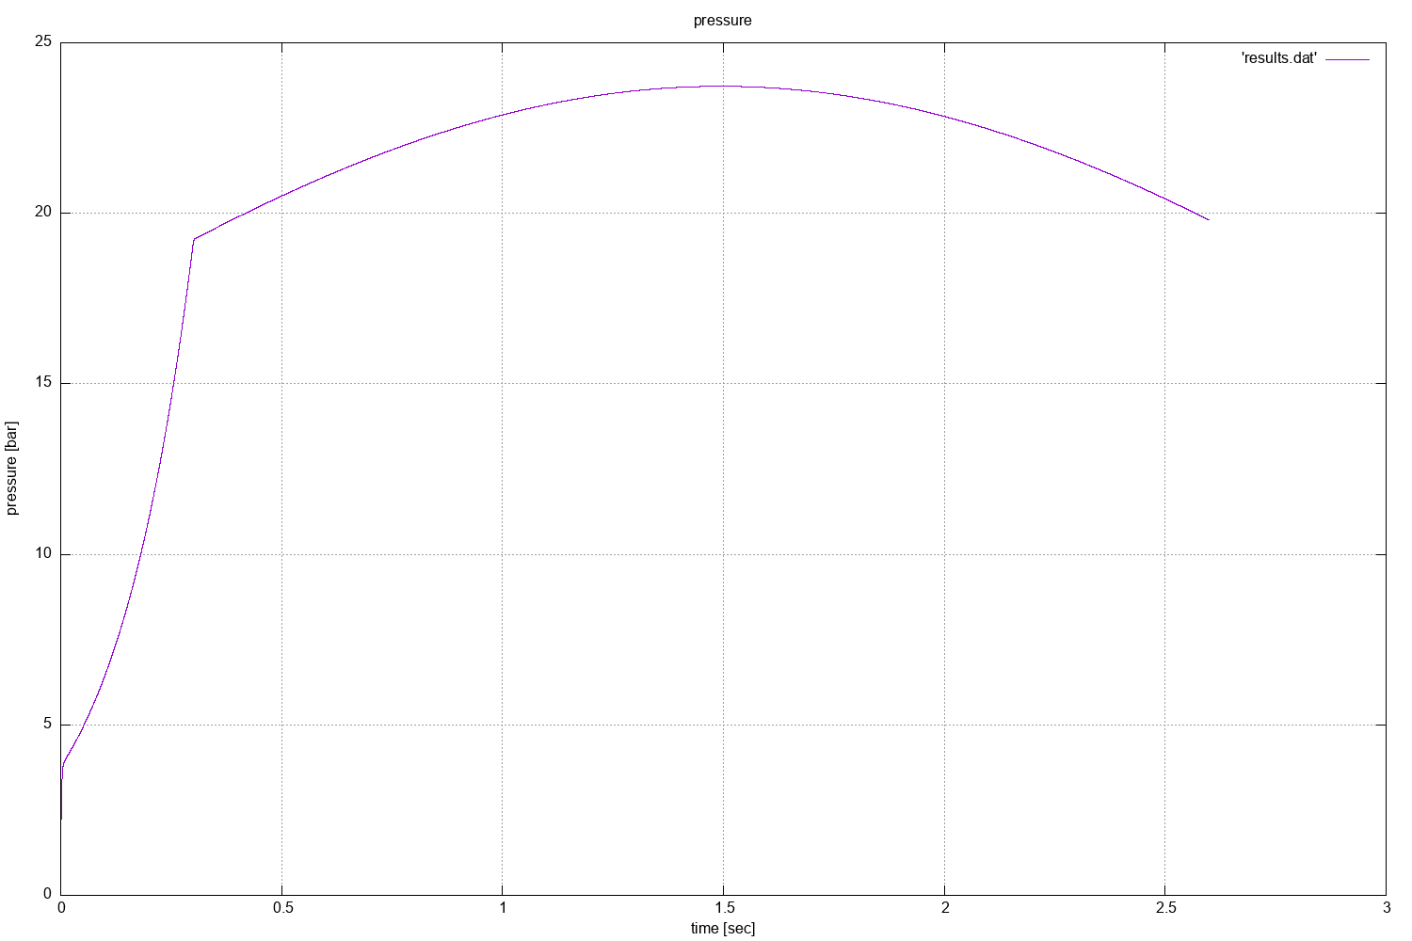

**Picture 3.11:** A more accurate model using exponential growth of the temperature inside the CC.

To find a sufficient thickness for the casing we use the following equation:

Where is the maximum stress acting on the casing, is the maximum pressure inside the CC, D is the inner diameter of the CC and the minimum thickness. Substituting with and solving for, we get:

Where SF is the safety factor, chosen by the designer (typical values, 1.5, 2, 3) and is the yield strength of the material.

The final important parameter we need to address, is the characteristic velocity of the motor, , a variable indicative of the combustion efficiency. We will also use the characteristic velocity in the next chapter, to calculate the specific impulse of a motor. C-star is given by equation 3.21:

Where is the initial mass of the propellant.

The integral is calculated using a numerical method. In the ChamberPressureSolver.hpp file a trapezoidal method method is used.

1. **Converging – diverging nozzle**

The final part of the engine is the nozzle. It’s an axcisymmetric tube which accelerates the hot gasses to maximize the thrust. It’s shape can be seen bellow:

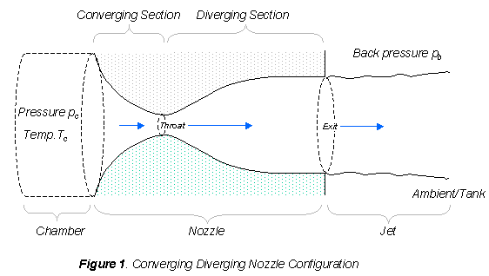

**Picture 4.1:** Converging – diverging nozzle.

The thrust is given by the following relation:

Where:

is the mass flow rate exiting the nozzle

is the velocity of the exiting gasses

is the area of the exit plane

is the pressure of the gasses at the exit of the nozzle

is the ambient pressure (atmospheric)

With a first look someone could imply, that by increasing the exiting pressure, the thrust is increased, but this is not the case. Optimized thrust occurs when , as we will see later in this chapter.

So lets begin the analysis of the nozzle:

As we saw in chapter 1, the velocity at the exit can be expressed using equation 1.7.

Using the isentropic relations (1.10) and the perfect gas law the exit velocity is given by equation 4.2:

For the mass flow rate we combine equations 4.2 and 2.5:

In the following graph we see how the normalized flow rate changes with pressure ratio:

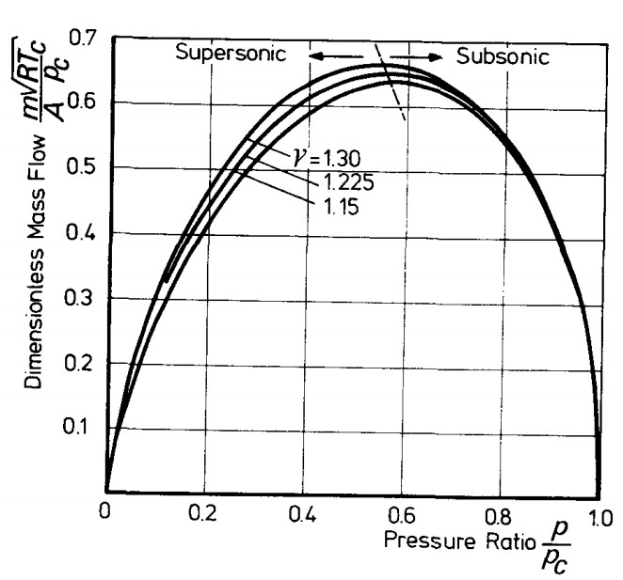

**Picture 4.2:** Graph of normalized flow rate (undimentional) and pressure ratio.

By differentiating the function we calculate the following:

Where

For the value and using equation we conclude that the mach number must be equal to 1, M = 1.

For a converging – diverging, this can only occur at the throat. This can be explained by the following relation, which is derived using continuity equation, the momentum equation, the energy equation and the isentropic relations:

For subsonic flow (M<1), for a positive change dV>0 there must be a negative change in the cross section area, dA<0. But if the flow is supersonic (M>1),then there must be a positive change in the area. That phenomenon is seen a converging – diverging nozzle. In the converging part, the flow is accelerating but remains subsonic. Then at the throat the flow becomes sonic (M=1). If the diverging part didn’t exist, then the flow would remain sonic. Having a diverging part, we can accelerate the flow even further.

That’s why equation 4.4 becomes:

With equations 4.6 and 4.3. we can derive an expression which is a function of pressure ratio and area ratio:

Using the continuity equation we can derive also, an expression of area ratio, as a function of Mach number ratio:

Using the ratio of the exits to the throats area and assuming that the flow is choked (), equation 4.9 transforms into a very important relation. An Area – Mach number Relation (AMR):

This equation, solved for the Mach number, given the area ratio has 2 solutions. One is subsonic (M<1) and one supersonic (M>1).

The importance of the AMR will be seen in the next chapter.

Having found expressions for the mass flow rate and the exit velocity as functions of the chamber and throat properties the thrust equations becomes:

If we calculate the optimum , by solving the equation , the solution is

And this is the optimal exit pressure for the nozzle.

The last concept that can affect greatly the performance of the nozzle, is the appearance of normal shocks in the supersonic-divergent region.

Α shock is generated when the the flow cannot reach the exits boundary conditions (in our case are the velocity, the pressure and the temperature in the atmosphere). This problem is overcome by a sudden and non isentropic process, a shock. Should it occurs inside the nozzle, then it’s a normal shock, else wise an oblique shock. Downstream the shock, the entropy has increased, the flow from supersonic has become subsonic, the static pressure has decreased, the density has decreased, the temperature has decreased, the total temperature has not changed and the total pressure has decreased. These changes can be seen in the figure bellow:

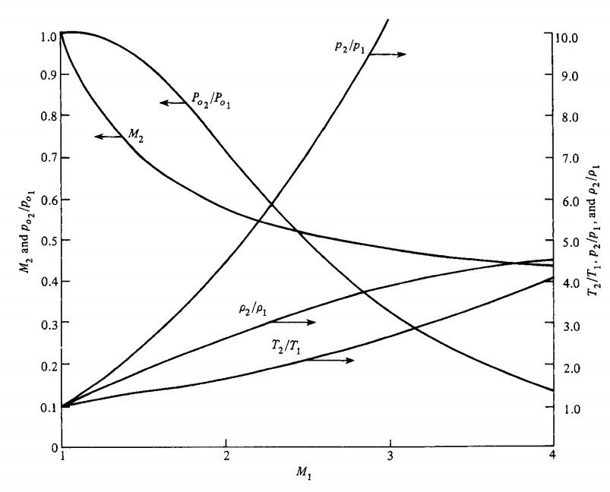

**Picture 4.3: Changes in all the variable across a normal shock.**

The ratios of the variables downstream the normal shock (after) to the variables upstream the normal shock (before) are given by the following expressions. The ^ index refers to the downstream conditions.

But the question still remains. When and where does a normal shock occurs?

The answer is analyzed, by using the figure bellow:

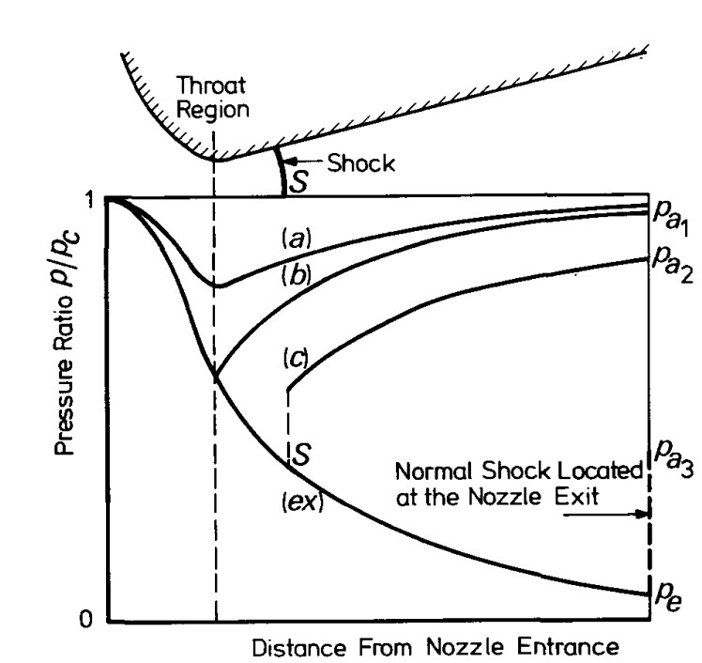

**Picture 4.4: Pressure distributions inside the nozzle for different ambient pressures.**

Let’s think the following noetic experiment. Let’s assume that pc is constant and that we can change the ambient pressure and as the experiment progresses we decrease its value. At the begging we see that the flow accelerates till the throat, decelerates then till the exit with subsonic velocity from the CC till the exit. We then decrease the ambient pressure. The Mach number increases in the throat but always remains under the value of 1. The gas also always reaches the ambient pressure at the exit (). At a certain value of pa (pa1), the flow becomes choked () and then decelerates into a subsonic flow, exiting the nozzle with a pressure equal to the ambient. Lowering the ambient pressure, develops a supersonic region inside the divergent part, but cannot be sustained, because normal shock occurs (line c). After the normal shock the flow is subsonic and the gas exit the nozzle with . If we reduce even more the ambient pressure (), then the normal shock is developed exactly at the exit. After this critical value, the flow will always be supersonic inside the divergent region and will exit the nozzle at . The flow will then adjust to the ambient pressure , by forming expansion waves and oblique shocks outside the nozzle, as it can be seen in the picture 4.5.

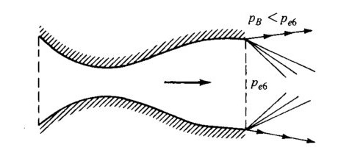

**Picture 4.5: The formation of expansion waves outside an under expanded nozzle.**

In this case the nozzle is called **under expanded nozzle.** We continue the experiment and reduce the ambient pressure till . This is the optimal point. I f we reduce the ambient pressure, then the flow will still be supersonic till the exit, but oblique shocks will occur at the exit and after the exit. In this case we talk about an **over expanded nozzle**, as we see in the following picture:

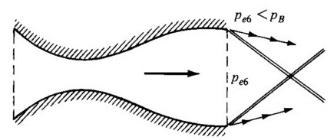

**Picture 4.6: The formation of oblique shocks outside an under expanded nozzle.**

To answer the question of, where does a normal shock occurs, the steps are the following:

1. Calculate λ
2. Calculate
3. Calculate
4. Calculate M using equation 4.15
5. Calculate using equation 4.9 (AMR)